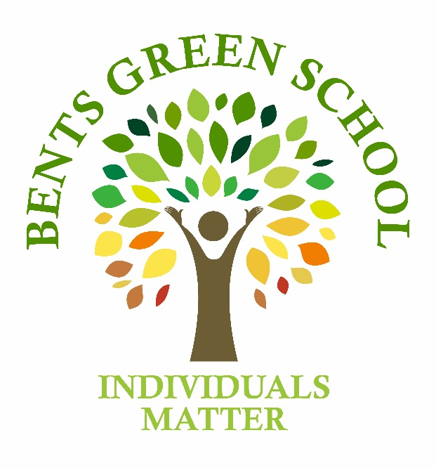

Bents Green School Learning Community

STRATEGIC PLAN

2018-2021

We are pleased to share with staff, parents and students our Strategic plan for the next three years.

This plan has been developed by the Governing Body to set a clear strategic direction for the school so that we are continuing to make progress in improving the offer and outcomes for all our students and the extended school community.

Any comments or suggestions are welcome.

Please contact: Sacha Schofield – Headteacher

Laura Gillespie – Chair of Governors

Contact details:

0114 236 3545

[enquiries@bentsgreen.sheffield.sch.uk](mailto:enquiries@bentsgreen.sheffield.sch.uk)

1. Background

Bents Green School

Bents Green School is a maintained specialist secondary school in Sheffield. The school is the central hub for the Bents Green Learning Community, the community incorporates Bents Green Specialist School, a Learning Hub at Westfield School, Post 16 at Sheaf Vocational College, and other provisions to enable bespoke personalised learning opportunities.

We currently have 189 students on roll across the three sites.

We provide education for young people aged 11-19 with Autistic Spectrum Conditions and Communication and Interaction Difficulties. Our philosophy is founded on a desire to make a difference. Within the Bents Green Learning Community, we ensure our young people get every opportunity to achieve their full potential in life. Our aim is to enable every student to flourish by encouraging and building upon their unique strengths and interests. We recognise the importance of developing every student’s social, emotional and personal development. This is supported by ensuring each student strengthens their independent and living skills which are key to building confidence and self-esteem. We are immensely proud of the students within Bents Green Learning Community and we are excited and committed to delivering high quality provision – driven by our desire to continually improve practice.

1. The Planning Process

The School’s Strategic Plan has been developed by Governors and Senior Leaders and sets out our Vision, Values and the Key Objectives that we will need to achieve if we are to realise our vision To **B**e a **G**reat **S**chool Community.

The plan is the basis for the School’s educational and financial planning, monitoring and evaluation processes, the plan will be reviewed and updated annually.

An integral part of the strategic planning and monitoring process is the school’s development plan, this is a working document that sets out for each strategic objective:

· Our development strategies and key actions

· Key Performance indicators for monitoring progress

· Timescales and the resources required

· Leadership and governance leads

· Success criteria and outcome measures

The school development plan is used by the governing body and leadership team to monitor progress against our strategic objectives.

In order to inform our forward planning process, we have analysed the school’s current strengths and weaknesses, looked at the external opportunities that may help us to achieve our goals and the potential external threats that could prevent us from realising our vision for the school. This information is shown in the strengths, areas for development, opportunities and threats analysis in section 5.

As part of our planning process we have also held a number of strategic planning workshops, the purpose of these workshops has been to:

* identify strategic developments and actions that build on the school’s strengths and make the most of the external opportunities.
* identify options for improving areas of weakness in the school and mitigating potential external threats.
* provide an opportunity for governors and staff to develop their skills, knowledge and understanding of strategic planning

1. Vision and Values

**Our Vision is:**

To **B**e a **G**reat **S**chool Community

We will achieve this by developing an inspirational outstanding autism provision that promotes the enjoyment and aspirations within the Bents Green Learning Community

**Our values which will help to deliver this vision are:**

Providing a welcoming and safe learning environment

Being open and honest

Caring and encouraging

Making Bents Green an enjoyable place to be

Learning together

Celebrating the individual

Working collaboratively with others

Developing an ethos of respect, trust and team work

1. Key Objectives

Our 6 key strategic objectives are:

Objective 1 – *To deliver a curriculum that meets the needs of all pupils and will inspire and engage the students in their learning and personal development in preparation for their journey to adulthood*

* To develop an admission’s process with the local authority that ensures Bents Green is the right placement so that pupils admitted to the school will always receive an inspirational and engaging education that meets their individual needs and that can be delivered in a safe, supportive and effective way
* To provide support and help to potential students and their families with transition and Educational Health Care planning, support and review
* To continuously improve our curriculum offer to provide pupils with a flexible curriculum that differentiates between and meets the needs of individual pupils
* To scope Post 16 provision to include provision for social care and up to 25 years in order to prepare young people for adulthood

Objective 2 - *To provide quality assurance of the teaching and learning in school by the continuing development of integrated monitoring and reporting systems for attainment, the quality of teaching and behaviour and safety*

* Develop a system of performance management that links in with monitoring the quality of teaching, continual professional development and the coaching triad management process
* To set aspirational targets for students, engaging parents in the process through the parental engagement programme and staff within the professional development programme
* Develop the learning community across our multi-site provision by encouraging the voice of students and staff
* Continue the development of lessons study by using the research pilot to grow confidence within tutor groups. The Social Communication, Emotional Regulation and Transactional Support model will be used to underpin the 7 C”, Communication, Craftmanship, Collaboration, Confidence, Creativity, Curiosity, Commitment and soft skill developments
* Evidence for learning targets will be derived from the students Educational and Health Care Plan (EHCP)
* As a research school we will use other models of educational research to grow our classroom practice
* To achieve outstanding teaching and learning within the personal, social, health and citizenship education (PSHCE) model
* To ensure safeguarding and online-safety policies are properly embedded and effectively applied in order to establish outstanding practice and to keep the students of Bents Green Learning Community safe and happy
* To embed Evidence for Learning assessment system to record and monitor student progress linked to EHCP outcomes and aspirational targets.

Objective 3 – *To develop strategies to improve communication and engagement with all stakeholders and partners in the Bents Green Learning Community and wider community*

* Parental engagement – Frequency of parent evenings, open evenings, transition events. Development of the governor role in parental engagement
* Engage with all stakeholders through focus groups, surveys, pro-actively seeking feedback from users and customers of the Bents Green Learning Community
* Further development of the school website and social media to provide helpful information and advice on autism and to market the school and learning community effectively
* Review and develop the school’s internal and external communication systems and processes to continuously improve information for all stakeholders.
* To develop clear reporting methods of student progress.
* To develop communication and engagement strategies with the Local Authority and localities.

Objective 4 – *To work collaboratively with partner organisations and stakeholders to enhance learning, develop and provide specialist services to the wider learning community, to engage effectively with other stakeholders in the development of special needs services and to make the Bents Green Learning Community an outstanding provision and centre of excellence*

* Identify current and potential partners / stakeholders, develop the vision for our future partnership and stakeholder arrangements
* Set out the key strategic business objectives that will steer the growth and development of our partnership and stakeholder collaborative working
* Ensure written agreements are in place for all current and future partnership and collaborative working arrangements
* To develop Bents Green as a National Support School by working towards accreditation of National Leader of Governance, National Leader of Education and Specialist Leader of Education. This will enable us to work collaboratively with other schools to support the development of outstanding teaching and learning for young people with autistic conditions.
* Develop the governor role to include a more proactive role in the School’s engagement with parents, enabling them to listen and communicate effectively with parents.
* To further develop the ethos of hubs and partnership agreements for Westfield and Sheaf Training.

Objective 5 - *To develop on-site and off-site provision that is fit for purpose and will provide pupils and staff with a flexible and safe learning*

*environment*

* Establish the optimal future size and purpose of the school in light of the increasing number and complexity of pupils admitted to the school
* Undertake a review of the current space available to the school to identify how it might be used differently or more flexibly in order to effectively meet curricular and pupil needs
* Investigate the opportunity to develop the use of alternative on-site buildings
* Review and look to improve and develop the current use and management of offsite provision
* To develop multi-site provisions.

Objective 6 - *To create a financially stable school that can support the curriculum and be able to invest in the growth and development of the Bents Green School Learning Community*

* Develop our income generation activities
* Maximise financial efficiencies through a programme of best value and school process reviews
* Share costs and create economies of scale through the development of partnership and collaborative arrangements
* Consider the employment of therapeutic staff to improve provision and achieve efficiencies
* Actively seek tri-party funding for appropriate pupils
* Develop bids for grant funding
* Ensure pupils admitted to the school are appropriately funded in accordance with the needs identified in their individual EHCP and that

Bents Green can effectively and safely support the pupils from the funding it receives

* Fully cost the school’s strategic development plan to ensure it is affordable within the school’s current and future financial plans
* Set fund raising targets for the Friends of Bents Green (FOBG)
* Repay the schools historic deficit over the next 3 years

|  |  |
| --- | --- |
| BENTS GREEN ANALYSIS | |
| **Strengths- What the school does well**   * Good strategic leadership of the school and Quality First Teaching * Development of school based National Leader of Governance, National Leader of Education, Specialist Leaders of Education * Skills mix and experience of staff and governors * On-going staff and governor development * Safeguarding and pastoral systems are robust * Financial control systems and processes * Business and financial planning * A good mix of skill and experience amongst staff and governors * Performance management process * Coaching and mentoring triads * Processes in place to ensure probity and regularity in the management of the school’s resources | Areas for Development – Could be working more efficiently  * The school benefits from being in fantastic grounds but with an inflexible footprint * Developing multi-site provisions * The school currently does not have a clear admission policy * The current cost of personalisation activities * Evidence for learning is a new initiative and is not fully embeded * links between monitoring the quality of teaching & learning and the school’s performance management systems * Parental engagement and involvement in early stages of development * Communication with stakeholders * Partnership and collaborative arrangements |
| **Opportunities – Improve school services**  Development of Outreach services locally and regionally   * Researching and evidencing good practice * To be a National Support School * To provide support for EHC planning and review * Grant bidding * Income generation * Shared and collaborative working arrangements * Westfield and Sheaf Partnership Agreements & Free School | Threats – External factors that could affect the school  * LA admissions process * Increasing number of pupils and complexity of need * Access to cost effective therapeutic services * Historic deficit * School Funding Cuts * Competition in the SEND market * Localities developing own provision * Free School |

1. Analysis

6. Monitoring and Evaluation Framework

|  |  |  |  |
| --- | --- | --- | --- |
| **Resources/Finance Committee**  **Chair – John Plant**  **Terms of Reference** | **Teaching and Learning**  **Chair – Laura Gillespie**  **Terms of Reference** | **Parents and Community**  **Chairs – Hilary Hoult**  **Terms of Reference** | **Strategy**  **Chair – Laura Gillespie**  **Terms of Reference** |
| Strategic Financial Management   * Policy * Planning * Controls * Monitoring * Review   Premises  Human Resources  Risk Management | Pupil progress – interventions and resources (pupil premium)  Timetables  Whole Curriculum planning and delivery  Pupil progress including pupil premium analysis / evidence  Data Analysis  Accreditation  Vocational learning  NQT Programme mentor  Staff induction | Partnerships  Website  Gibson House  Safeguarding  Inclusion Opportunities  Enrichment Activities (off site)  Vulnerable groups including LAC/ CIN  Attendance  SENCO  Risk Assessments  Transitions overview (Y7-14)  Personalisation monitoring  Safeguarding including E-safety | Strategic Partnerships  Local Authority  Learn Sheffield  Mercia TSA  Fusion  TSA  Multi-Academy Trust Exploration  Regional Teaching School Application  Developing future provision to meet the needs of changing student population |
| **SLT Member**  **Sacha Schofield**  **Debbie Ireland** | **SLT Member**  **Sacha Schofield**  **Claire Bailey** | **SLT Member**  **Claire Bailey** | **SLT Member**  **Sacha Schofield** |